**Bucket Creation**

1. Navigate to Services → Storage → S3.
2. Choose a unique, globally valid bucket name (no uppercase or invalid characters)
3. Select a region for the bucket.

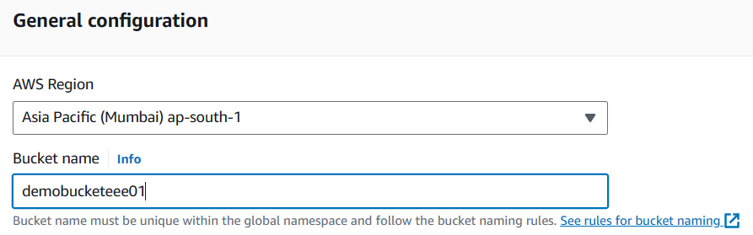

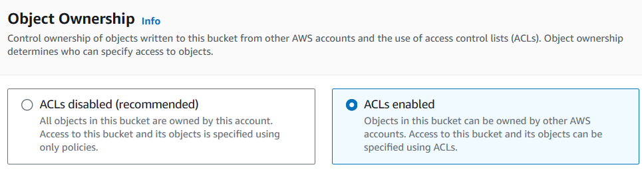

1. Uncheck "Block Public Access" during creation.

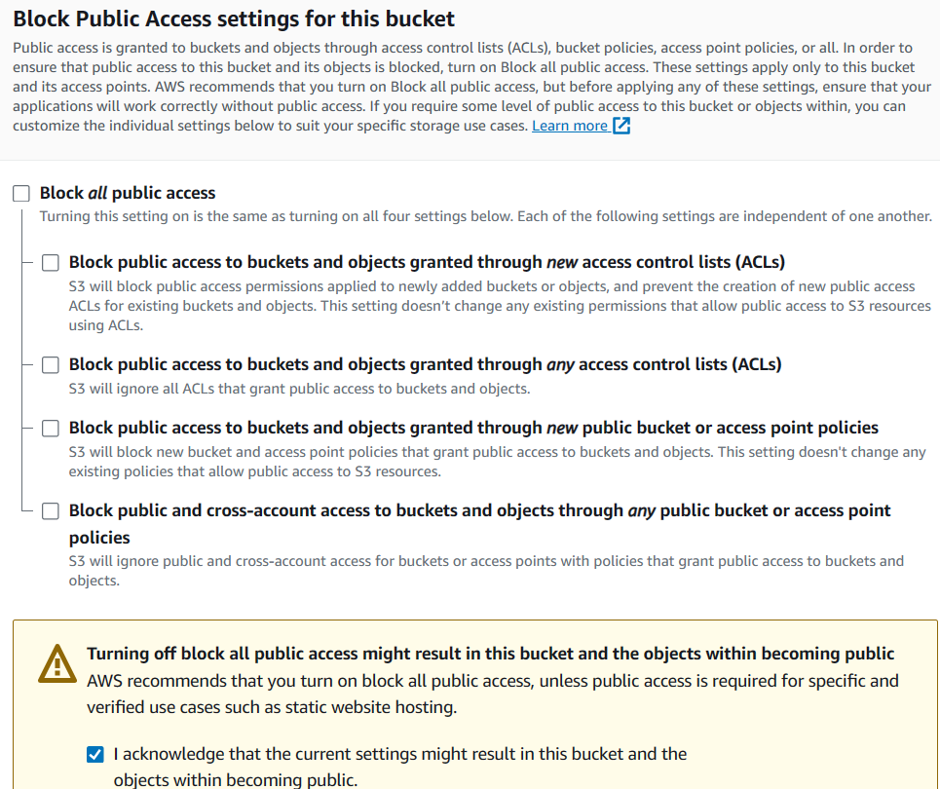

**Note:** Buckets are globally available and not confined to specific regions like EC2 machines.

**Observation:** We can see global in dashboard.

Create another bucket in different region

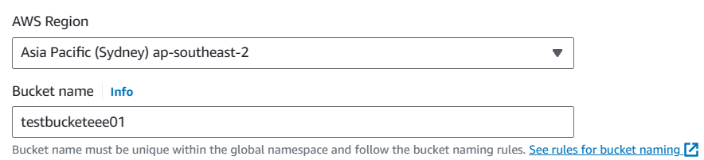

**Observe:** Both the buckets are available in the same dashboard.

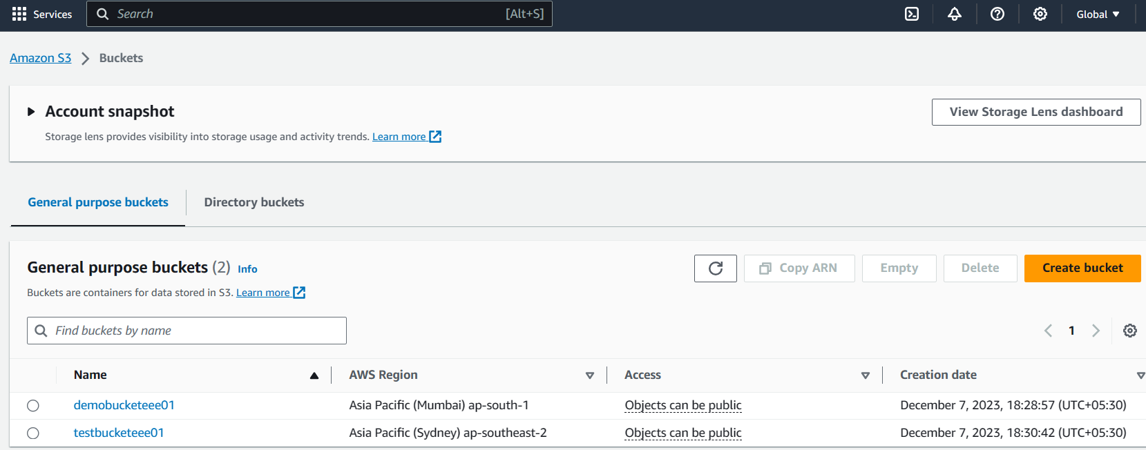

**Uploading Objects:**

1. Click on the created bucket.
2. Upload files, grant public permissions if needed.
3. Objects in a public bucket are accessible globally via Object URL.
4. Make an object private by editing permissions.

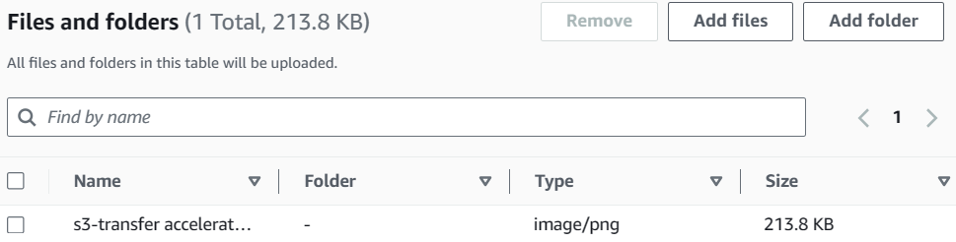

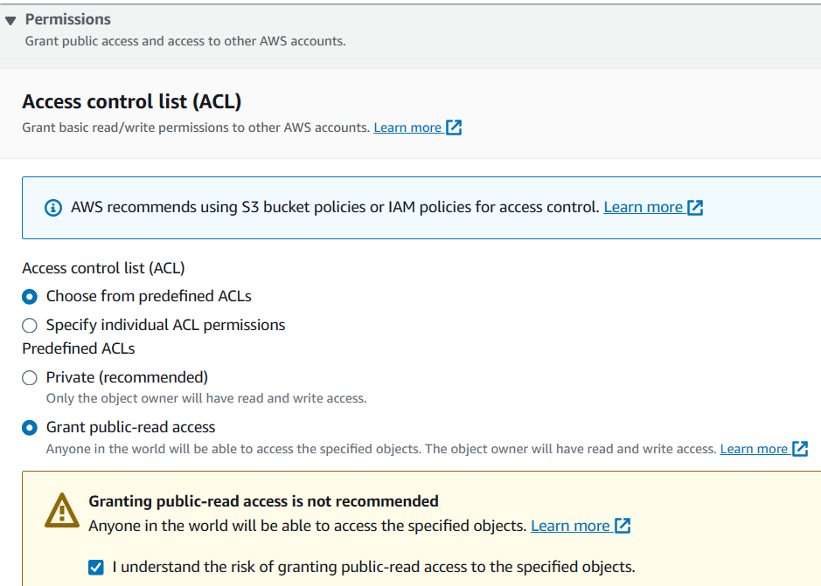

* Click on the Object > Get Object URL.
* Using Object URL, anyone can access.
* Copy the URL and paste it in browser you can access the object because it is publicly readable.

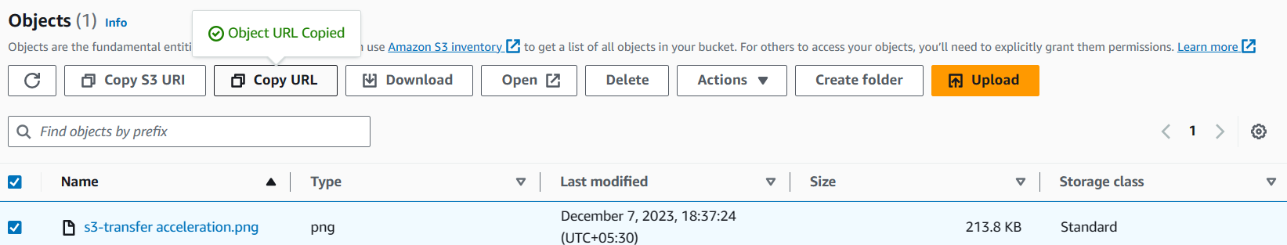

Note: As bucket is public, and object is also public, anyone in the world can access the content.

URL accessibility can be controlled via permissions.

"Read everyone" grants public access.

**How to make the object private?**

Click on the bucket > select object > Permissions > Edit > Uncheck read access

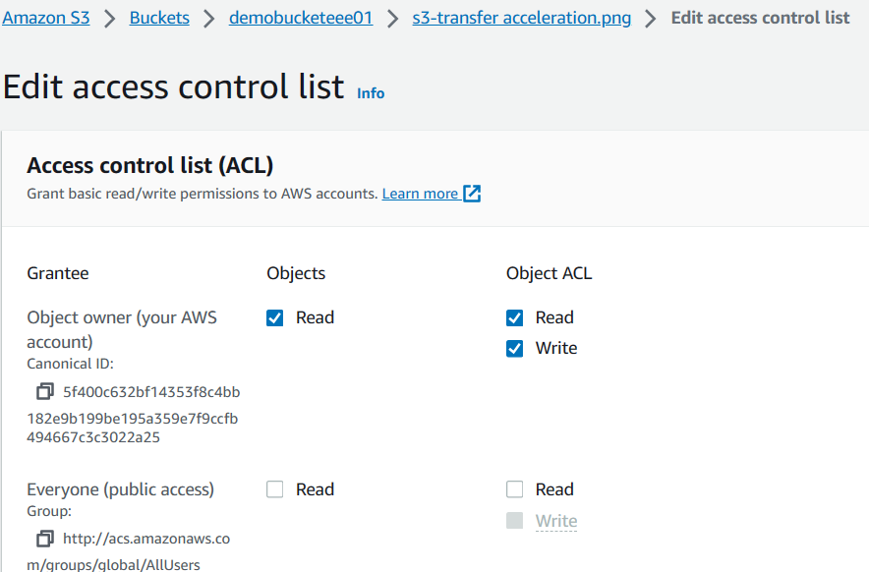

If you check the url. It is access denied now.

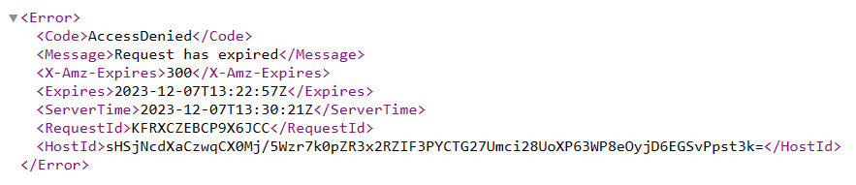

To make it available to public edit permissions.

**Versioning:**

* Enable versioning to keep multiple versions of an object.
* This allows you to recover deleted or overwritten objects.
* You can see all versions of an object and download them individually.

**How to enable versioning?**

1. Enable versioning under Bucket Properties.

(Observation: By default, version is disabled)

1. Edit --- Enable

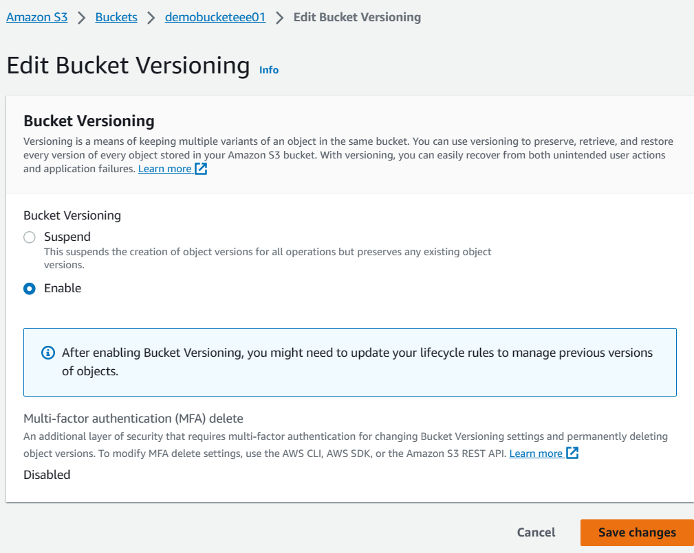

Upload a simple text file with content “My First Line”

1. Save Changes.
2. Upload an object

**Advantage of versioning:**

1. Recover deleted objects by listing versions.

Delete the object by selecting the object > Delete

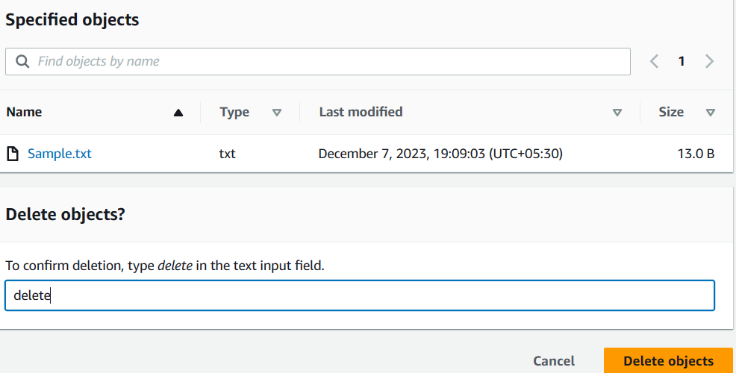

To recover the object, enable list version.

You can see the object and its delete marker.

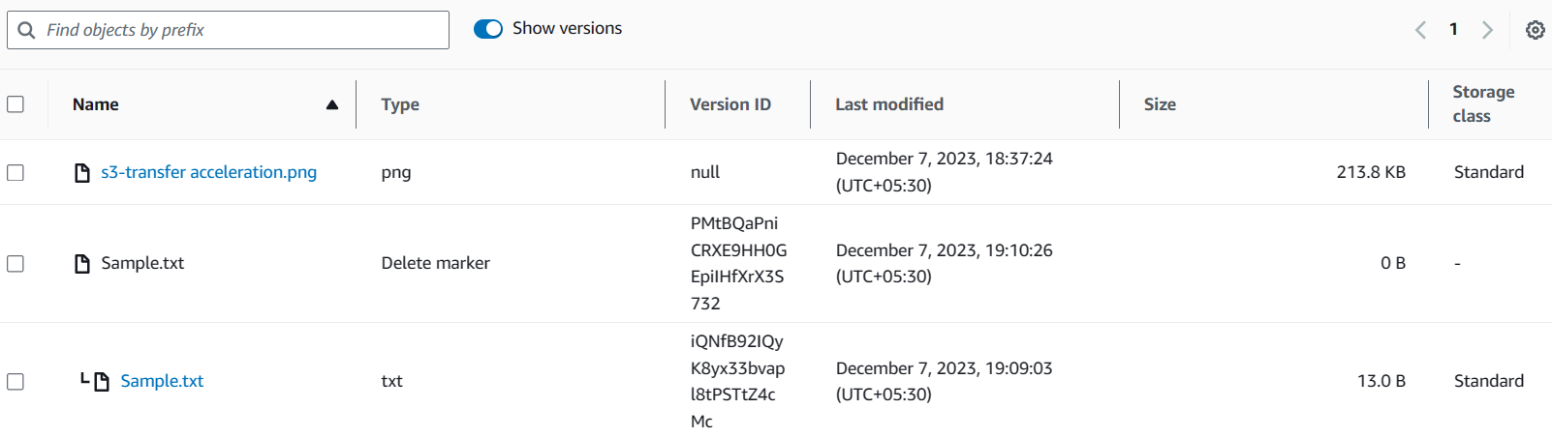

**Note:** Deleted objects are marked, not removed.

If you delete the delete marker, we will get the object.

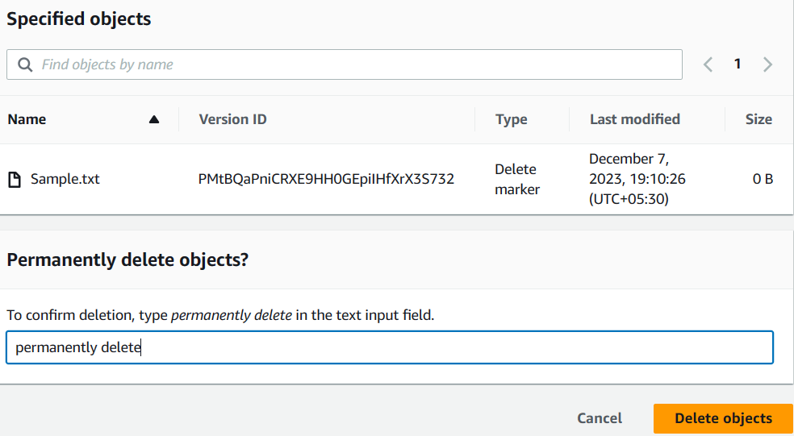

Now, Disable list version

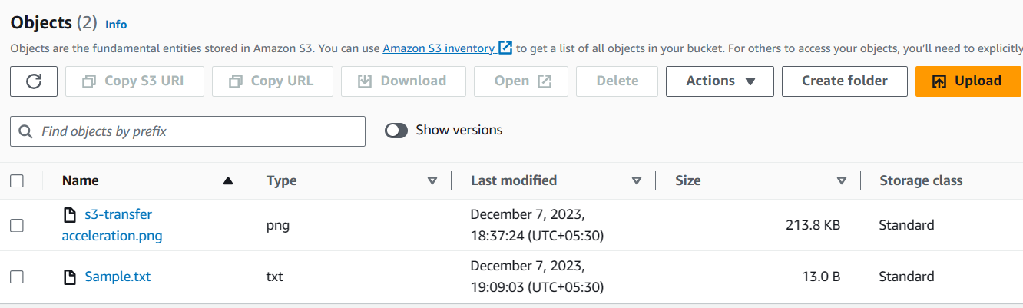

Our object is back!!!

1. Versions can be maintained for files; each upload creates a new version.

Open the same file in your desktop and add another line "My second line"

Upload the same file again.

Get the object URL, and check from browser, we get the latest file.

**To see the older versions of the file?**

Show list version

You can see both the versions

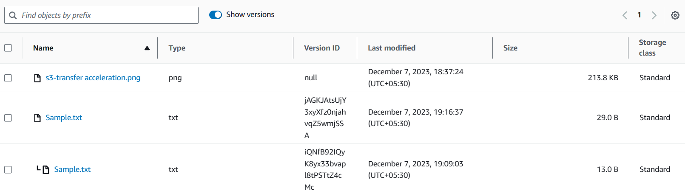

And you can download the older versions of the file.

**Note:** Even if you delete the file, we can recover both the versions.

If you delete individual versions, we cannot recover. Also, if you delete bucket, we cannot recover.

**Static website hosting**

1. Create a bucket, enable static website hosting under Properties.
2. Add index.html and error.html.

index.html - <h1>Welcome to S3 Bucket!</h1>  
error.html - <h1>Error page. Please try again</h1>

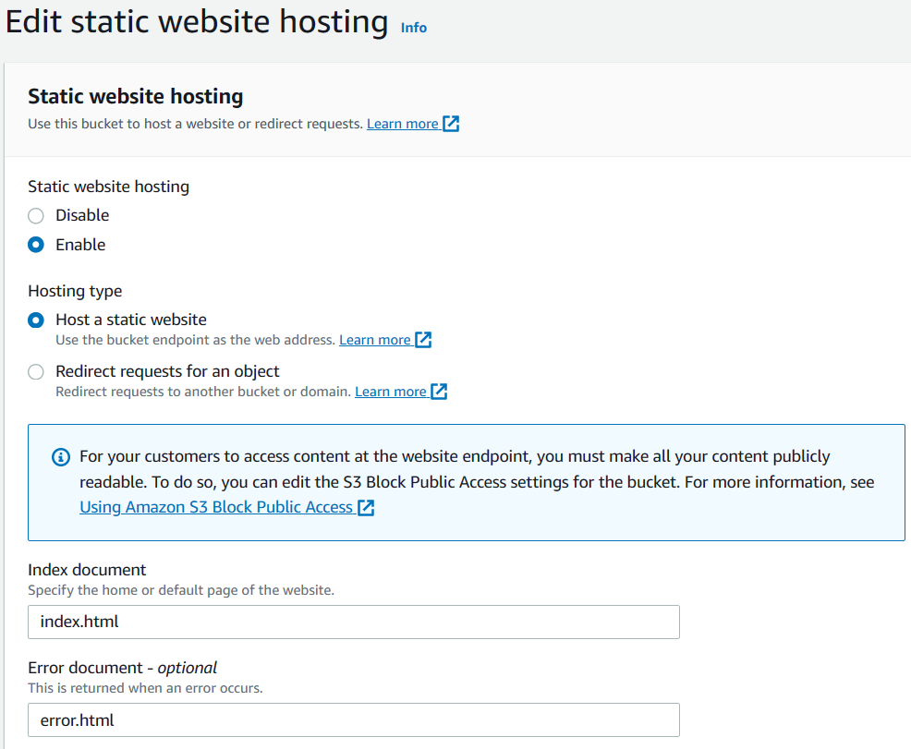

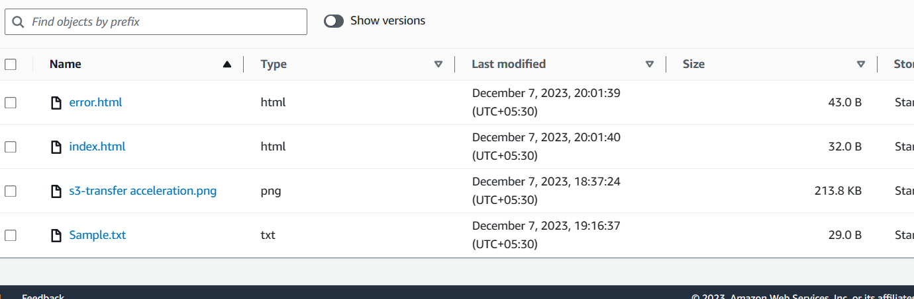

1. Go to the properties of the bucket > Static website hosting > get URL of the website (endpoint)

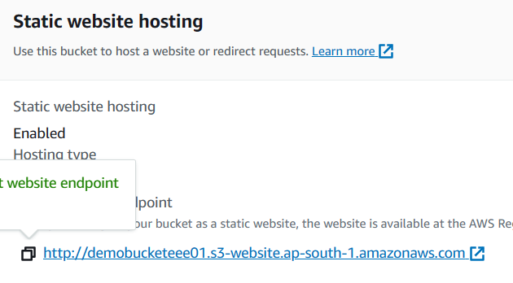

Make sure the filename should be same in what you mention in static website hosting. Also, make sure the object permissions.

Note: Individual files should have public access.

**What is the use of error.html?**

In case of any reason, if index.html is not accessible then error page will be displayed.

Make the index.html page as private by selecting index.html > ACL > Edit > public access > read - uncheck - Save Changes

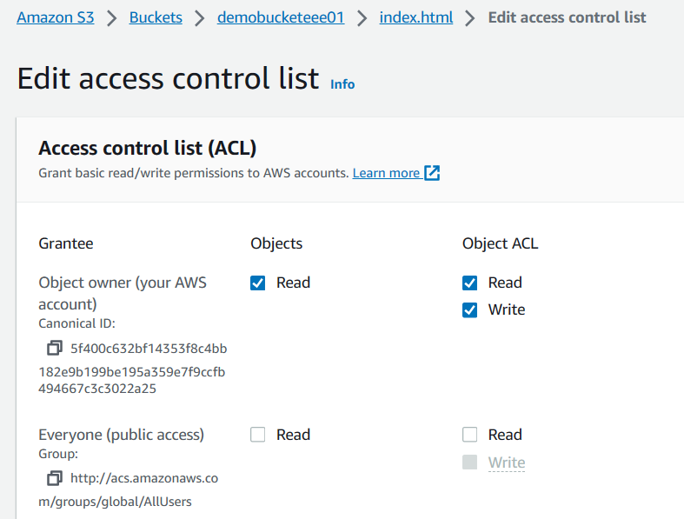

Now, refresh the URL, you will get the error.html page!!!